Candidate Number: 48372
Word Count (Excluding Graph Notes & Bibliography): 994

As a data scientist who is working on re-training the NHS AI system for lung cancer diagnosis, I would present an important ethical concern about the fairness of our AI system to the manager: the accuracy of our model performs unequally across different ethnic groups. In this article, I will first explain the reason for this phenomenon, counter some opposing arguments, and finally provide my opinions in addressing this problem.

The major reason for this fairness concern (inequality in the performance of AI across different ethnic groups) is due to the deficiency of training data for certain ethnic groups. There are 2 reasons for this data deficiency: 1, the different population of ethnic groups in the UK, and 2, the difference in the likelihood of getting lung cancer between ethnic groups. According to the 2021 UK Census (UK Government, n.d.), 82% of the population in England and Wales are white. Thus, even if we hold the probability of getting lung cancer constant, minor ethnic groups like Black, Mixed, or Asian naturally have smaller samples that are available for NHS hospitals to collect, due to their smaller population in the UK.

However, the probability of getting cancer itself is neither constant. From research led by Delon et al. (2022), in Figure 1, we find that the probability of getting cancer for Asian, Black, and Mixed ethnicity is significantly smaller than White ethnicity in England, which applies to both men and women, albeit to varying degrees. Because the population in England is more than 80% of the total UK population, it could be reasonably deduced that this finding remains valid when it is scaled up to the whole UK. Therefore, after explaining these 2 reasons for data deficiency, I could deduce that the NHS lung cancer data that we are using to retrain the AI now is mostly constructed by White samples.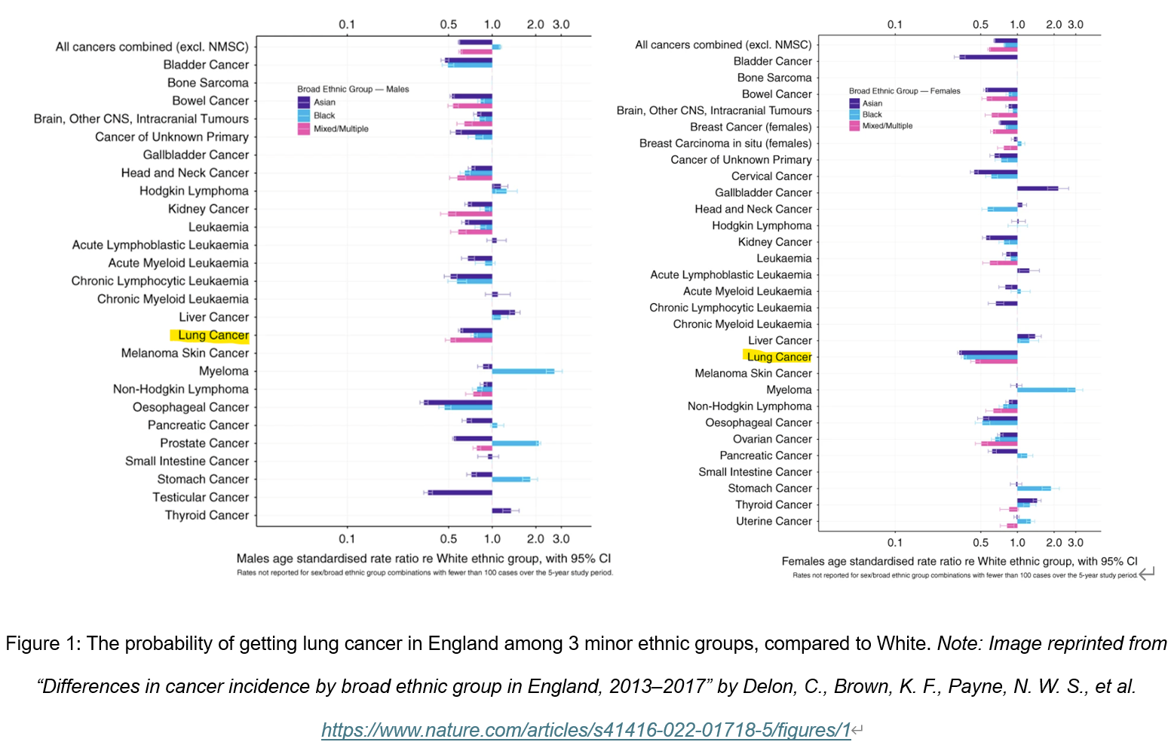

When we involve this AI in the diagnosis process of lung cancer in our NHS hospital, it causes fairness problems due to the unequal accuracy across different ethnic groups. If the training data is mainly from White ethnic groups, the AI diagnosis would be built using their past biological information to predict which is correlated to the presence of lung cancer. However, under-represented ethnic groups differ from whites in many aspects like allele frequency and genetic variation, therefore the AI has a higher probability of providing wrong diagnoses (False Positive and False Negative results) to them compared to Whites. This accuracy gap, unfortunately, is not small because of both smaller sample numbers and a smaller likelihood of getting cancer for under-represented ethnic groups.

However, I have also heard an opposite argument, that under-represented groups have 'selection freedom': they can opt out of AI in favor of human doctors. But if we introduce our AI, instead of providing a higher quality service to a fixed number of patients, our hospital would increase the number of patients it serves per day. This is because the introduction of AI improves the efficiency of lung cancer diagnosis compared to human diagnosis. This reduces the availability of patients to see a human doctor, because the number of doctors is the same despite the increase in patients, "forcing" patients to choose a flawed AI diagnosis rather than personalized individual care (Sunstein, 2022). Thus, the quality of service received by under-represented ethnic groups is in fact unfairly harmed by the introduction of AI whose error distribution is unequal across different ethnic groups.

Another opposing opinion is from the value-free argument: it claims that AI should operate without incorporating any ethical values, and should be treated as a neutral tool. Personally, I cannot agree with this opinion, as I think it could be countered by the inductive risk theory. The consequences of errors raised by AI can range from minor inconveniences to severe harm (Douglas, 2009). For instance, errors made by AI in filtering spam mail are less severe than errors in autonomous driving, because the latter leads to leads to human injury or even death. AI in medicine already carries a very high inductive risk (Betz, 2013), and our AI lung cancer diagnosis is even higher. Any misdiagnosis can lead directly to delayed (False Negatives) or incorrect treatment (False Positives) of patients.

One major recommendation to address this problem is to increase the coverage of training data for under-represented ethnic groups. We can both accumulate data from NHS hospitals within the UK, or from overseas, but neither of them is perfect. The UK has a diverse ethnicity, but the population for each is relatively small. When it comes to lung cancer, we have rather limited samples for some ethnic groups. However, we could collect data from targeted NHS hospitals in regions where many under-represented ethnic groups reside. If data is still insufficient, we may rely on data from aboard, but we have limited methods to verify their reliability, and their data structure may significantly differ from the harmonized NHS format.

Expanding data coverage is a long-term process, but there are other things we could do in the short term to tackle the fairness problem. Certainly, we need to increase the iteration of our lung cancer model to improve accuracy, but more importantly, I strongly advocate quantifying the accuracy of our model about different ethnic groups, and publishing it to all patients who use our model. We need to handle the “autonomy” back to patients themselves by increasing the transparency of our model.

In conclusion, I have described the major issue with our lung cancer diagnosis AI model: the fairness issue, in which the accuracy is unequal among different ethnic groups. This is caused by differences in sample sizes of training data across ethnic groups. After that, I countered 2 opposite opinions from my colleagues: the “selection freedom” opinion, and the “value-free” opinion. Finally, I have raised a long-term and a short-term solution, which respectively are: expanding data coverage of under-represented groups, and increasing transparency about the performance of AI to patients.

Bibliography:
Betz, G. (2013). In defence of the value free ideal. European Journal for Philosophy of Science, 3, pp.207-220. https://link.springer.com/article/10.1007/s13194-012-0062-x
Delon, C., Brown, K. F., Payne, N. W. S., et al. (2022). Differences in cancer incidence by broad ethnic group in England, 2013–2017. British Journal of Cancer. pp.1765–1773. https://www.nature.com/articles/s41416-022-01718-5
Douglas, H. E. (2009). Science, policy, and the value-free ideal. University of Pittsburgh Press. pp.44-66. https://books.google.com/books?id=LcFvKeOJRmgC
Sunstein, C. R. (2022). Governing by algorithm: No noise and (potentially) less bias. Duke Law Journal. pp.1185-1187 https://scholarship.law.duke.edu/dlj/vol71/iss6/1/
UK Government. (n.d.). Ethnicity facts and figures. https://www.ethnicity-facts-figures.service.gov.uk/

